PASCAL'S TRIANGLE IN ASIA
NAME(S): CLASS:
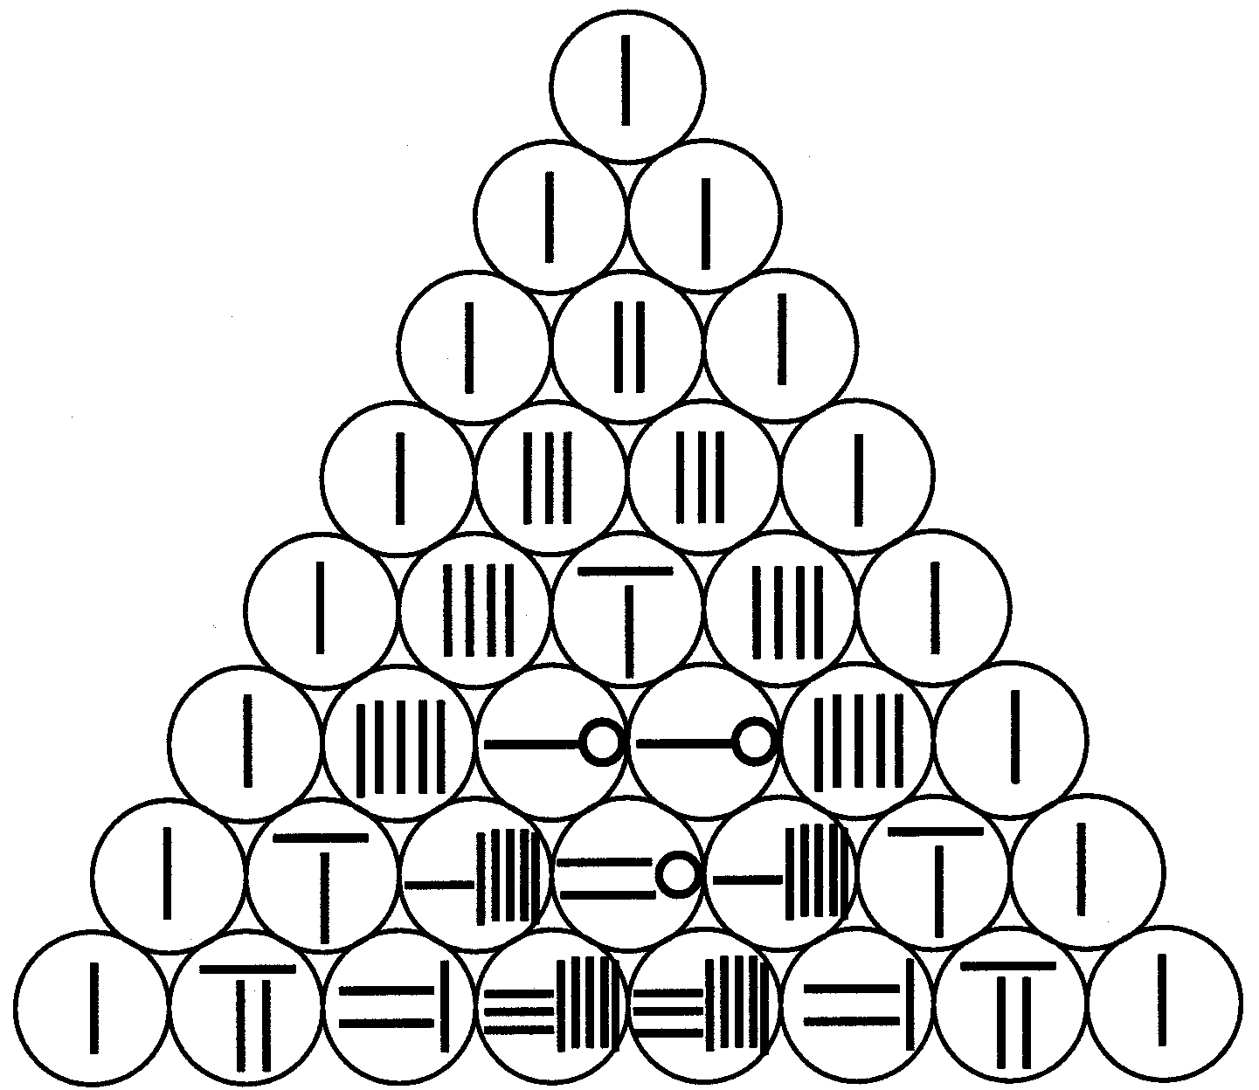

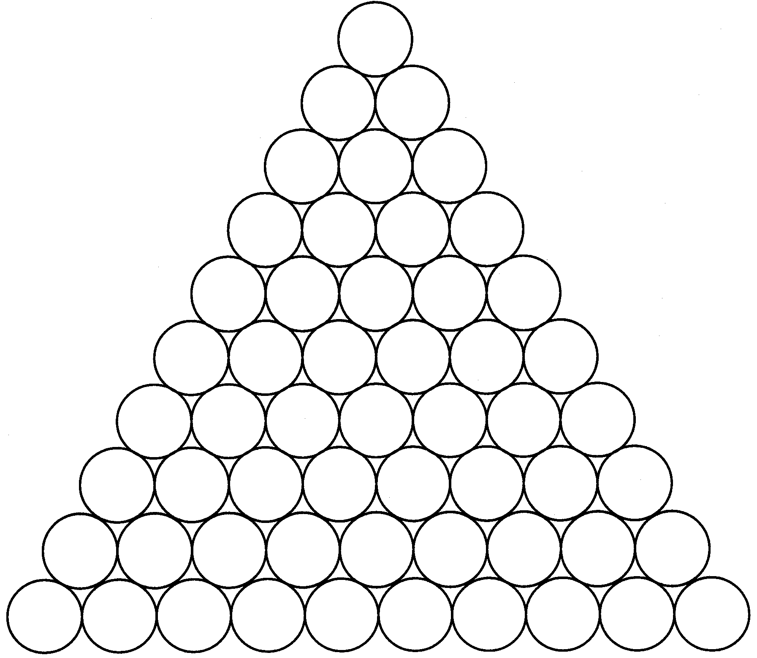
© Mathematics Task Centre Task 144 Reproducible Page

